Anglo-Chinese Junior College
H2 Mathematics 9740
Qn | Paper 2 Solution
1 (i)  (ii) | 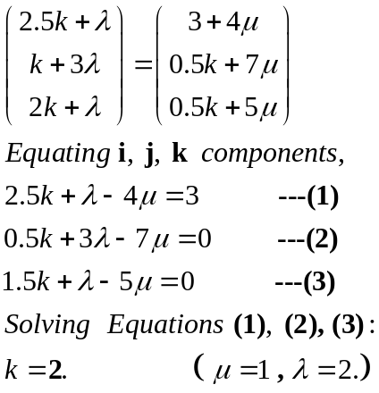  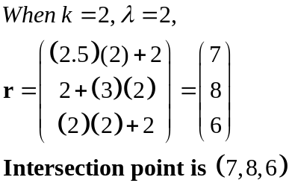
2 | Let   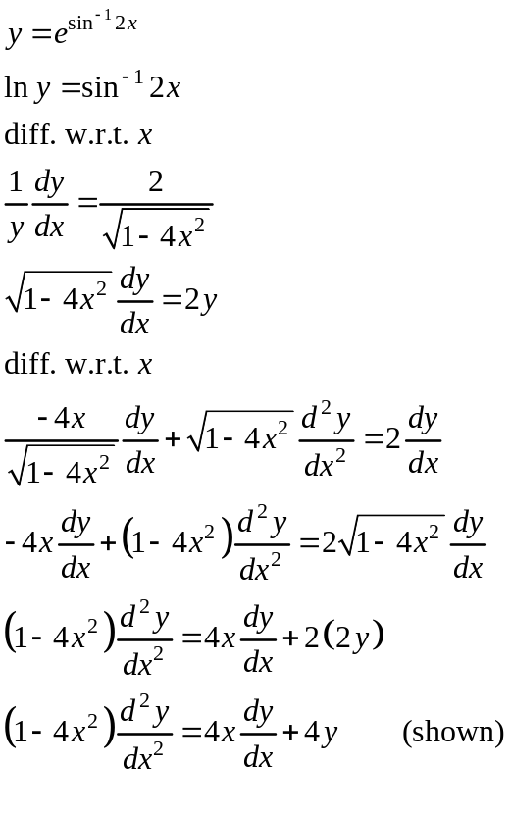  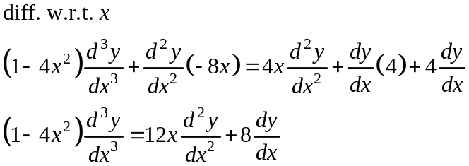  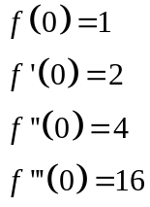  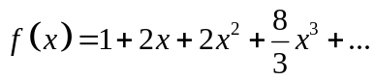  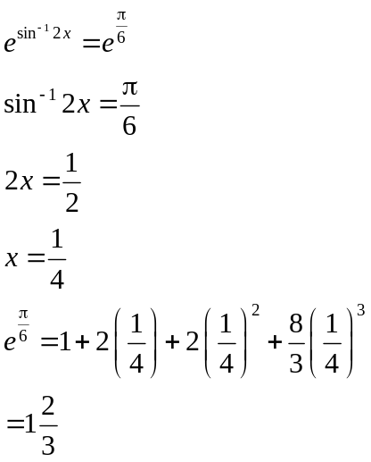
3i  ii  a)  b) | 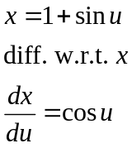  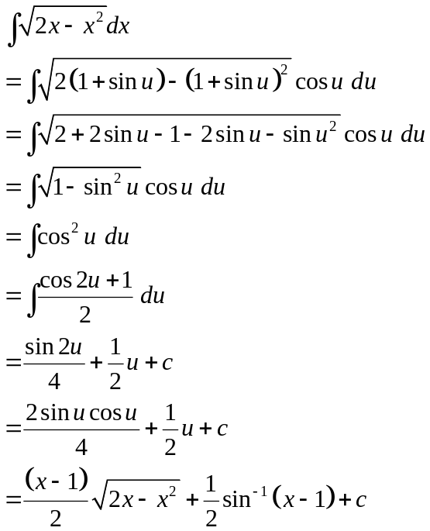  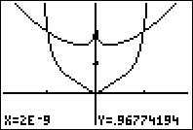  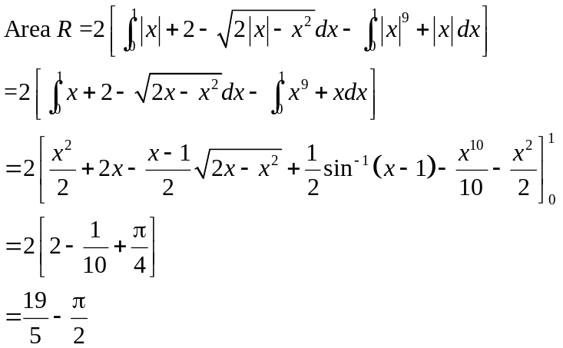  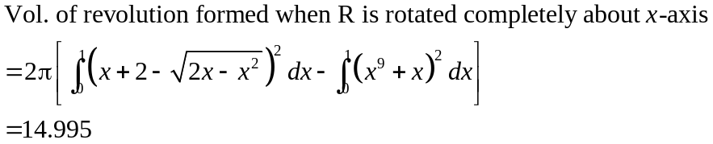
4 (i)  4(ii) | Method 1:  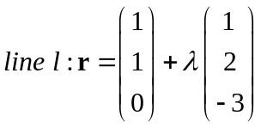  Since (1,1,0) lies on 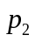,  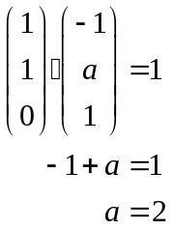  Method 2:  Since direction vector of line l is perpendicular to normal of ,  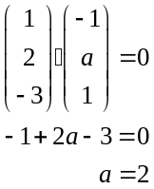  Method 3:  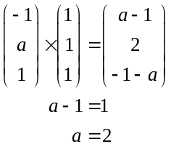  Method 1: Normal method  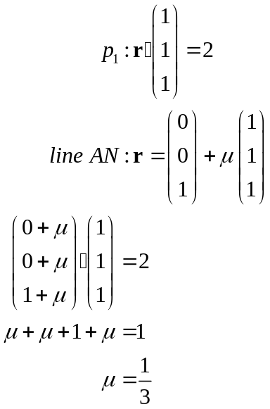  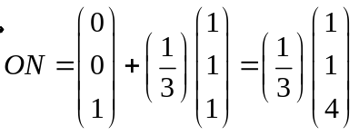  Method 2: Projection Method  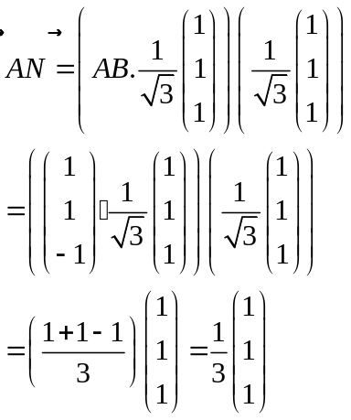  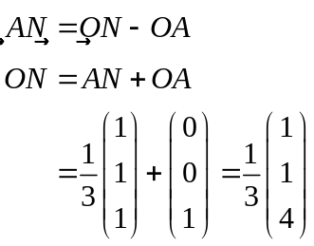
4  (iii) | Let the acute angle between planes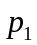 and be .  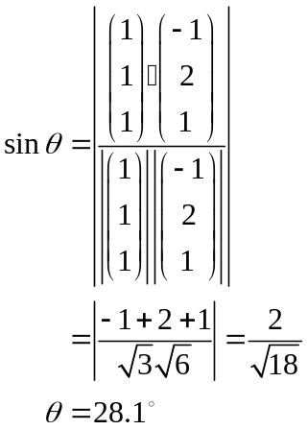
4  (iv) | Distance from Origin to p₁ 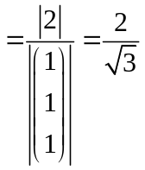  Distance from Origin to p₃ 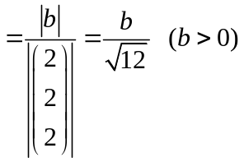  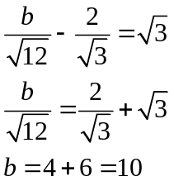
4  (v)  (vi) | , and 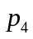 meet in a line l.  Hence (1,1,0) lies on .  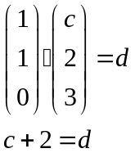  Normal of is perpendicular to line l.  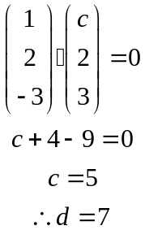  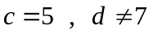
5 | Randomly choose 10 programmers, 1 secretary and 1 section head for the sample.  Stratified sampling guarantees a representative sample of each group (i.e. programmers, secretaries and section heads) in the population.  CANNOT accept any of the following answers:  ♦ “… allows the opinions of different strata to be considered separately.”  ♦ “… accurate …”  ♦ “… unbiased …”
6  (a)  (i)  (ii)  (b) | 4 boys and 3 girls  _ B _ B _ B _ B _ 4! × ⁵P₃ = 24 × 60  = 1440  Or 4! × (⁵C₃ × 3!) = 24 × 60 = 1440  G BBBB GG type so 4! × 4! = 576  Case (i): 3 boys and 3 girls  ⁴C₃ × (3 − 1)! × 3!  B  B  B  G  G  G  = 4 × 2 × 6 = 48  Case (ii): 4 boys and 2 girls  (4 − 1)! × ³C₂ × ⁴P₂  B  B  B  G  B  G  = 6 × 3 × 12  = 216  Or (4 − 1)! × ³C₂ × ⁴C₂ × 2! = 216  Total number of arrangements = 48 + 216 = 264
7 | 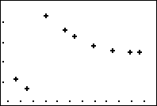  Plot of y against x.  x  y  4.4  12.3  2.7  6.3  Highest y = 6.3; Lowest y = 2.7  Highest x = 12.3; Lowest x = 4.4  Correlation coefficient = r = 0.263  A linear model is not appropriate as the scatter diagram shows that the points are not close to a straight line and the value of r is quite close to 0.
7 | For y = ax² + b, value of r = −0.913  For y = a ln x + b, value of r = −0.971  Therefore, (b) y = a ln x + b is a better model as the value of r in (b) is closer to −1 than for (a).  Line of regression is  y = 11.042 948 39 − 2.687 231 256 ln x  When y = 6.1, ln x = 1.839 420 548  - x = 6.29 (3 sf)  Accept x = 6.3 (1 dec place)  This estimate is valid since the value of r is close to −1 and the value of y used in within the range of experimental data (4.5 ≤ y ≤ 6.3).  Or, may say that x comes from interpolation instead of “within the range of experimental data”.
8(a) | Let X be the number of cars arriving at the jetty in 30 mins  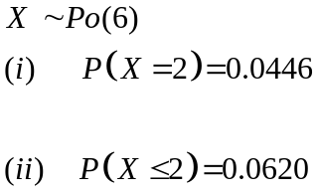
8(b) | Let Y be the number of cars arriving at the jetty in 20 mins  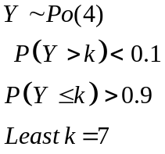
  k | 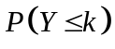
  6 | 0.88933
  7 | 0.94887
  8 | 0.97864
9  (a) | Let X be the time of journey from Town A to Town B.  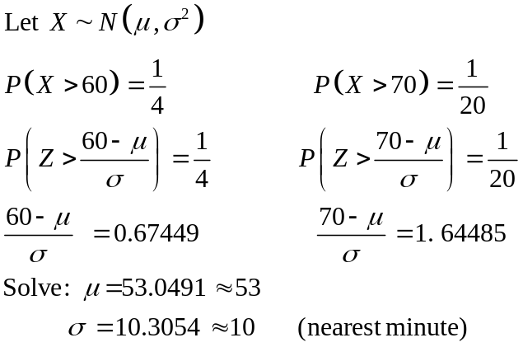
(b) | Let Y be the time of journey from Town B to Town C.  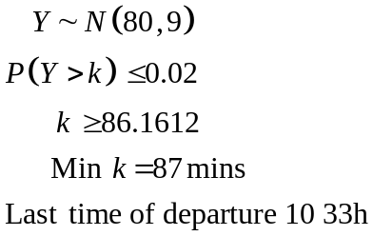
 | 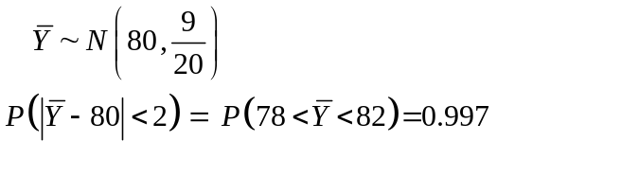
10 | Let L be the length and B be the breadth of a tile  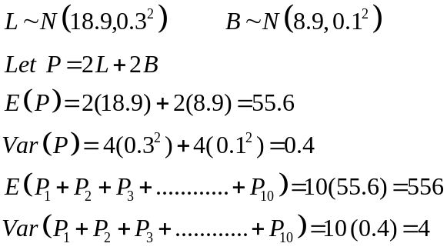
Let W be the number of tiles with a red tint.
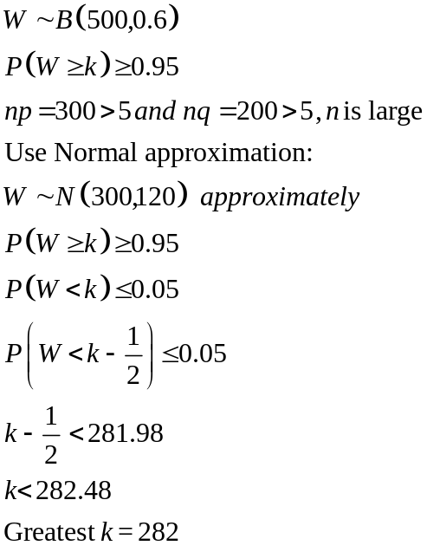
11 | 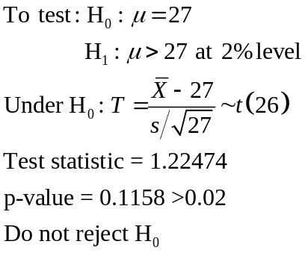  There is insufficient evidence at the 2% level of significance to conclude the mean foot length of an 18 year old man of high intelligence is more than 27cm  Assumption: Assume the population of foot length of 18 year old man of high intelligence is normally distributed
 | 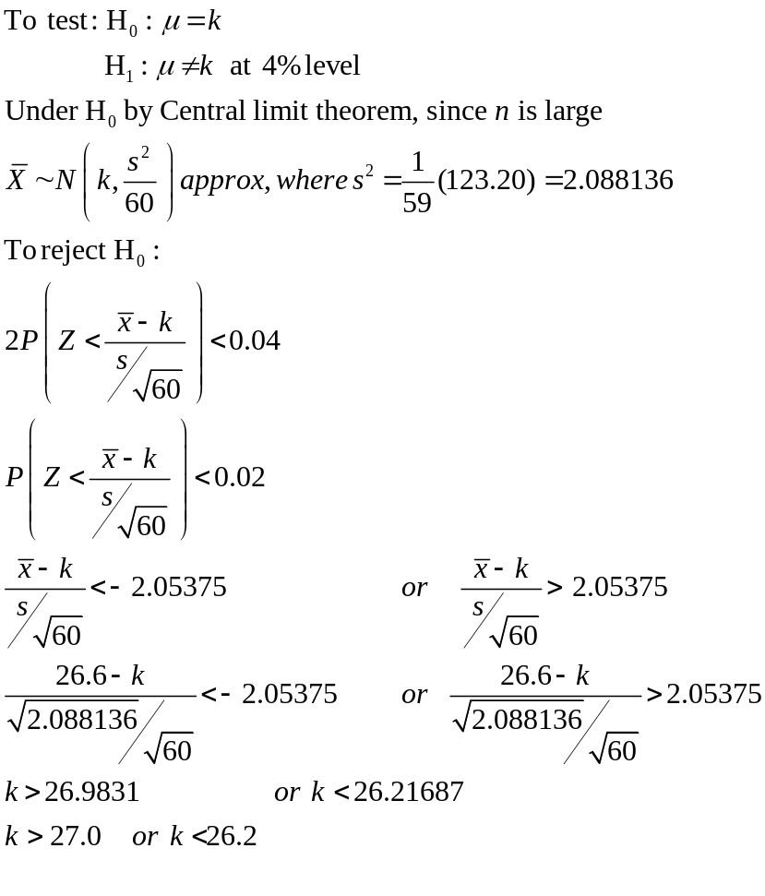
12 (i) | Let X be the r.v. “number of shots, out of 20, that hit the target”. X ~ B(20, 0.25)  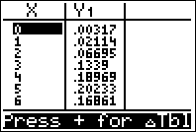  Most likely number of shots is 5.
12 (ii) | P(X ≥ 5 | X ≤ 10)  = 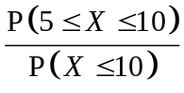  = 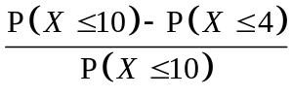  = 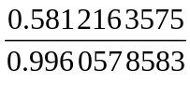 = 0.584 (3 sf)
12 (iii) | P(same number of shots each to hit target)  = P(1, 1) + P(2, 2) + P(3, 3) + …  = 0.25² + (0.75 × 0.25)² + (0.75 × 0.75 × 0.25)² + …  = 0.25² (1 + 0.75² + 0.75⁴ + 0.75⁶ + …)  = 0.0625 × 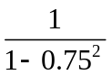  = 0.0625 × 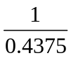 = 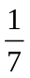 or 0.143 (3 sf)

